**Lab 06**

**Laboratory Exercise**

**LAB EXERCISE**

**What You Learn**

* Rcap preparing puppet-agent image and creating a puppet agent container

**Part 1**

**Time to Complete**

Approximately 45 Minutes

From your machine logged-in to RP VPN, run Remote Desktop Connection to connect to the ubuntu Linux Virtual Machine (VM). Please login based on your assigned VM as shown below:

|  |  |  |  |  |
| --- | --- | --- | --- | --- |
| **S/N** | **Student ID** | **IP Address** | **User Name** | **Password** |
| 1 | ABDUL SALIM BIN ABDUL RASHITH | 172.20.115.161 | dockeradm | docker!2 |
| 2 | LEOW YU HAN | 172.20.115.162 | dockeradm | docker!2 |
| 3 | CHAN JUN ZHI, GLENN | 172.20.115.163 | dockeradm | docker!2 |
| 4 | CHIA WAI TAT | 172.20.115.164 | dockeradm | docker!2 |
| 5 | HOI WAI TECK | 172.20.115.165 | dockeradm | docker!2 |
| 6 | ~~22053123~~ | 172.20.115.166 | dockeradm | docker!2 |
| 7 | KYAW KYAW OO | 172.20.115.167 | dockeradm | docker!2 |
| 8 | LUM YOKE FAI | 172.20.115.168 | dockeradm | docker!2 |
| 9 | MUHAMMAD FADHLI BIN MOHAMED NOOR | 172.20.115.169 | dockeradm | docker!2 |
| 10 | MUHAMMAD HILMEE BIN MD ALI | 172.20.115.170 | dockeradm | docker!2 |
| 11 | MUHAMMAD MUQTADIR BIN SADIQ BASHA | 172.20.115.171 | dockeradm | docker!2 |
| 12 | NG SAY WEE | 172.20.115.172 | dockeradm | docker!2 |
| 13 | NGUI WEILY | 172.20.115.173 | dockeradm | docker!2 |
| 14 | NU'MAN HARITH BIN NORRAIMI | 172.20.115.174 | dockeradm | docker!2 |
| 15 | RULY JANUAR FACHMI | 172.20.115.175 | dockeradm | docker!2 |
| 16 | SEAH SHIH WEI GEROME | 172.20.115.176 | dockeradm | docker!2 |
| 17 | SEAN CHENG ZHI WEI | 172.20.115.177 | dockeradm | docker!2 |
| 18 | ~~22053098~~ | 172.20.115.178 | dockeradm | docker!2 |
| 19 | TAN JOON YEE DOUGLAS | 172.20.115.179 | dockeradm | docker!2 |
| 20 | WU WAI TENG VANESSA | 172.20.115.180 | dockeradm | docker!2 |
| 21 | YAP KOON SING | 172.20.115.181 | dockeradm | docker!2 |
| 22 | LIM YE CHENG | 172.20.115.182 | dockeradm | docker!2 |
| 23 | CHAI RU YI | 172.20.115.183 | dockeradm | docker!2 |
| 24 | JWAY HWEE LING JULIE | 172.20.115.184 | dockeradm | docker!2 |
| 25 | SAMANTHA TEO XING YEE | 172.20.115.185 | dockeradm | docker!2 |
| 26 | ZIL AZZA HILMIAH BINTE RADUAN | 172.20.115.186 | dockeradm | docker!2 |
| 27 | ZIL AZZA HILMIAH BINTE RADUAN | 172.20.115.187 | dockeradm | docker!2 |
| 28 | SEY KOK SIONG | 172.20.115.188 | dockeradm | docker!2 |
| 29 | KOH JIN CAI DAEMIAN | 172.20.115.189 | dockeradm | docker!2 |
| 30 | Spare | 172.20.115.190 | dockeradm | docker!2 |
| 31 | Spare | 172.20.115.191 | dockeradm | docker!2 |
| 32 | Spare | 172.20.115.192 | dockeradm | docker!2 |
| 33 | Spare | 172.20.115.193 | dockeradm | docker!2 |
| 34 | Spare | 172.20.115.194 | dockeradm | docker!2 |
| 35 | Spare | 172.20.115.195 | dockeradm | docker!2 |

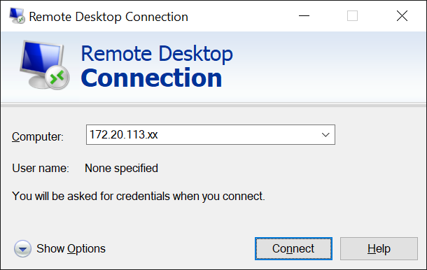

Replace xx with the IP address of the VM that you have been assigned.

In this lab you will create a new container with puppet agent installed and having an assigned static IP address. The followings are the overview of the tasks to be performed:

* Create a container
* Install puppet agent and commonly used packages
* Create image
* Create new container from image
* Create docker custom network
* Assign static IP to client container

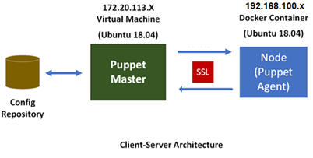

You should have already set up Puppet Enterprise (PE) on you VM. If not yet, please refer to lesson 1 and complete the PE setup.

1. On your VM, open **Terminal** and enter the following command to login as a superuser.

root@sddo-vm: **su**

*password: **ubuntu**

To add an entry or modify the hosts file, simply run the commands below to open the hosts file.

root@sddo-vm: **nano /etc/hosts**Make the change to the hosts file as per below (yellow highlight).

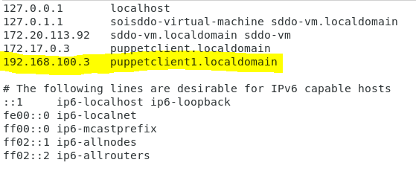

Save the file and exit.

2. Prepare a puppet-agent container image

2.1 Create a new container

root@sddo-vm: **docker run -it --name puppetclient1 -h puppetclient1.localdomain ubuntu:18.04 /bin/bash**

2.2 On new container, Install useful packages

**Fill in the purpose of the following each package:**

|  |  |
| --- | --- |
| **Package Name** | **Purpose** |
| **curl** |  |
| **wget** |  |
| **vim** |  |
| **iputils-ping** |  |
| **net-tools** |  |
| **openssh-server** |  |

root@puppetclient1: **apt-get update**

root@puppetclient1: **apt-get install curl wget vim iputils-ping net-tools openssh-server**

2.3 On the new container, install puppet-agent

root@puppetclient1: **wget --content-disposition 'https://pm.puppetlabs.com/puppet-agent/2021.5.0/7.14.0/repos/deb/bionic/puppet7/puppet-agent_7.14.0-1bionic_amd64.deb'**

root@puppetclient1: **dpkg -i puppet-agent_7.14.0-1bionic_amd64.deb**

2.4 Save container as image to local docker repository

root@sddo-vm: **docker commit puppetclient1 puppetclient-image**

2.5 Create a docker custom network

root@sddo-vm: **docker network create --subnet=192.168.100.0/24 customnetwork**

3. Create new container (with puppet-agent installed)

root@sddo-vm: **docker run -d - -network customnetwork --privileged -h “puppetclient1.localdomain” - -name puppetclient1 - -add-host “sddo-vm:172.20.113.92” - -ip “192.168.100.3” puppetclient-image /sbin/init**

(Note: Yellow hightlignted IP address is your Puppet Master)

For the various option used in docker run command, refer to <https://docs.docker.com/engine/reference/commandline/run/>

View your custom network information

root@sddo-vm: **docker network inspect customnetwork**

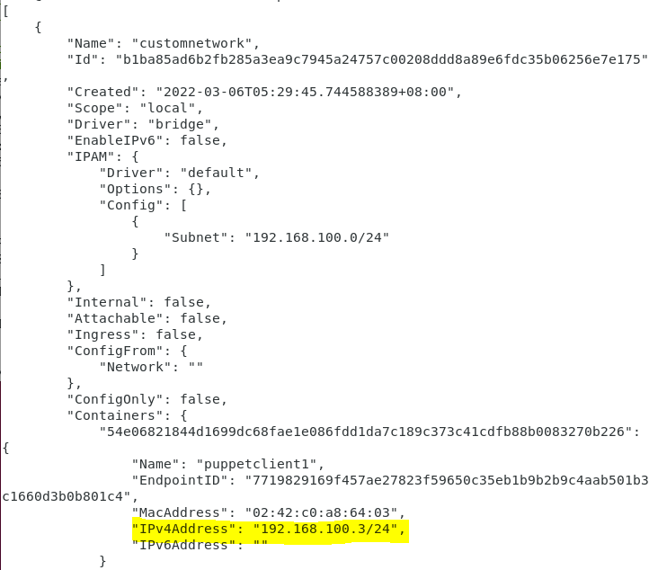

3.1 Verify the yellow highlight texts are already in the /etc/hosts file of the container.

(sddo-vm’s IP address should be your VM’s IP address)

root@puppetclient1: **cat /etc/hosts**

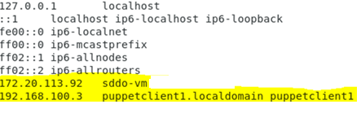

3.2 Configure puppet client setting

root@puppetclient1: **vim /etc/puppetlabs/puppet/puppet.conf**

Add the following texts (yellow highlight) into the file

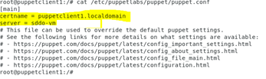

4. Register the puppet agent with the puppet master.

4.1 On the **client node (Puppet Agent)**, sends its **first request**.

root@puppetclient1: **/opt/puppetlabs/bin/puppet agent -t**

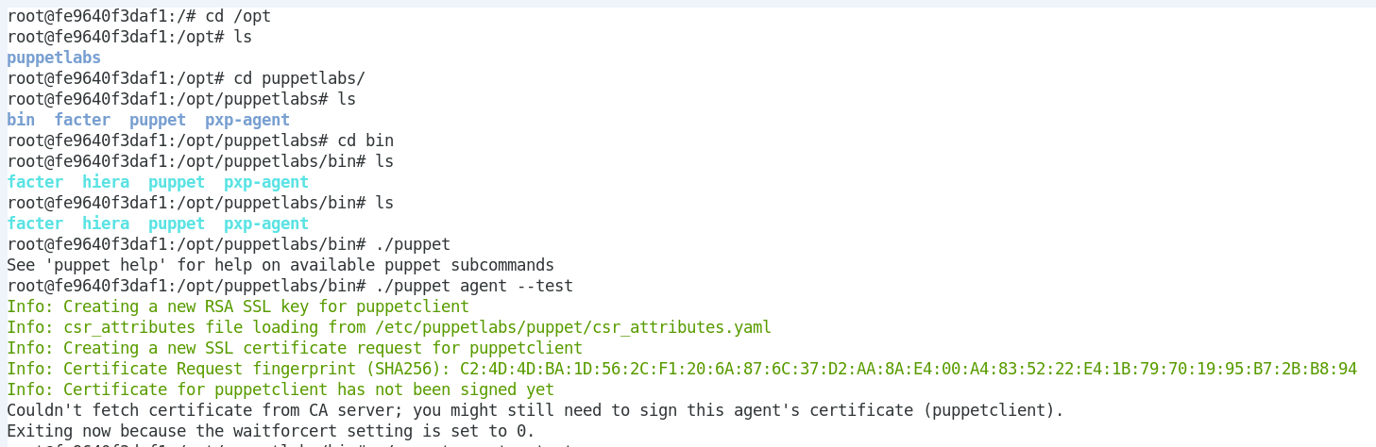

4.2 On the **server node (Puppet Master)**, list all the available certificates. Notice that the cert from the **client node (puppetclient)** is now shown.

On the **server node (Puppet Master)**, list all the certificates.

root@sddo-vm: **/opt/puppetlabs/bin/puppetserver ca list --all**

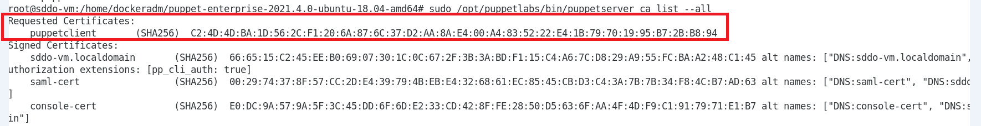  
  
Sign the requested certificates.

root@sddo-vm: **/opt/puppetlabs/bin/puppetserver ca sign --all**



5. On the **client node (puppetclient1)**, use the following command to test the communication between the server and client node.

root@puppetclient1: **/opt/puppetlabs/bin/puppet agent –t**

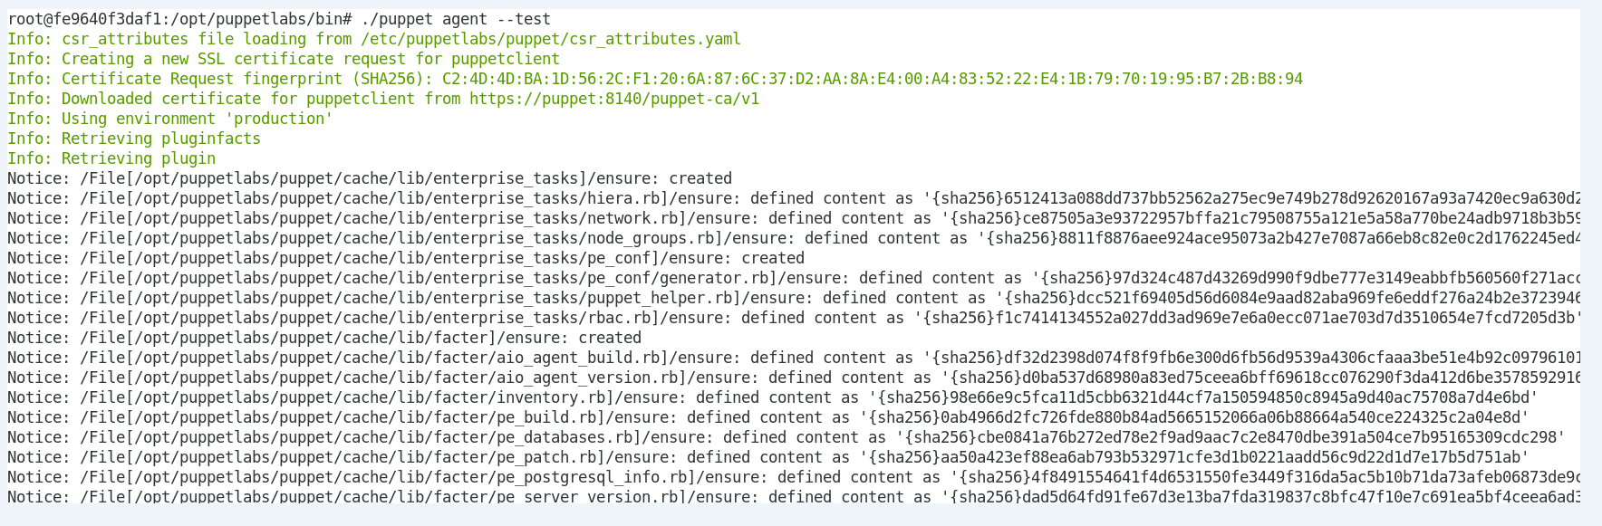

6. Extend your path variable to include the puppet command

In the container, edit ~/.bashrc file to make permanent modifications. Use a text editor like nano to open the file

root@puppetclient1: **nano ~/.bashrc**

append the file with the following

**export PATH=$PATH:/opt/puppetlabs/bin**

Force changes in current terminal session

root@puppetclient1: **. ~/.bashrc**

root@puppetclient1: **echo $PATH**



Test puppet command can be issued from any folder.

root@puppetclient1: **puppet agent -t**

(There should be error in the output)

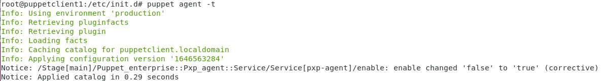

You have successful setup a container with puppet-agent running, assigned static IP address. We will use this container in subsequent lessons.

**Part 2**

**Time to Complete**

Approximately 15 Minutes

**Now, you should be able to create another puppet agent container. Based on the following information, create another puppet agent container.**

|  |  |  |
| --- | --- | --- |
| **Container Information** | **Setting** | **Remark** |
| **Container Name** | **puppetclient2** |  |
| **Docker image** | **puppetclient-image** | **Image was created earlier in this lab** |
| **Container IP Address** | **192.168.100.4** |  |
| **Custom Network** | **customnetwork** | **192.168.100.0/24** |
| **Container Hostname** | **puppetclient2.localdomain** |  |
| **Puppet Master** | **sddo-vm** |  |
| **Privileged Container** | **Yes** |  |

**--End of Lab Exercise --**